Write a query to find the addresses (location_id, street_address, city, state_province, country_name) of all the departments.

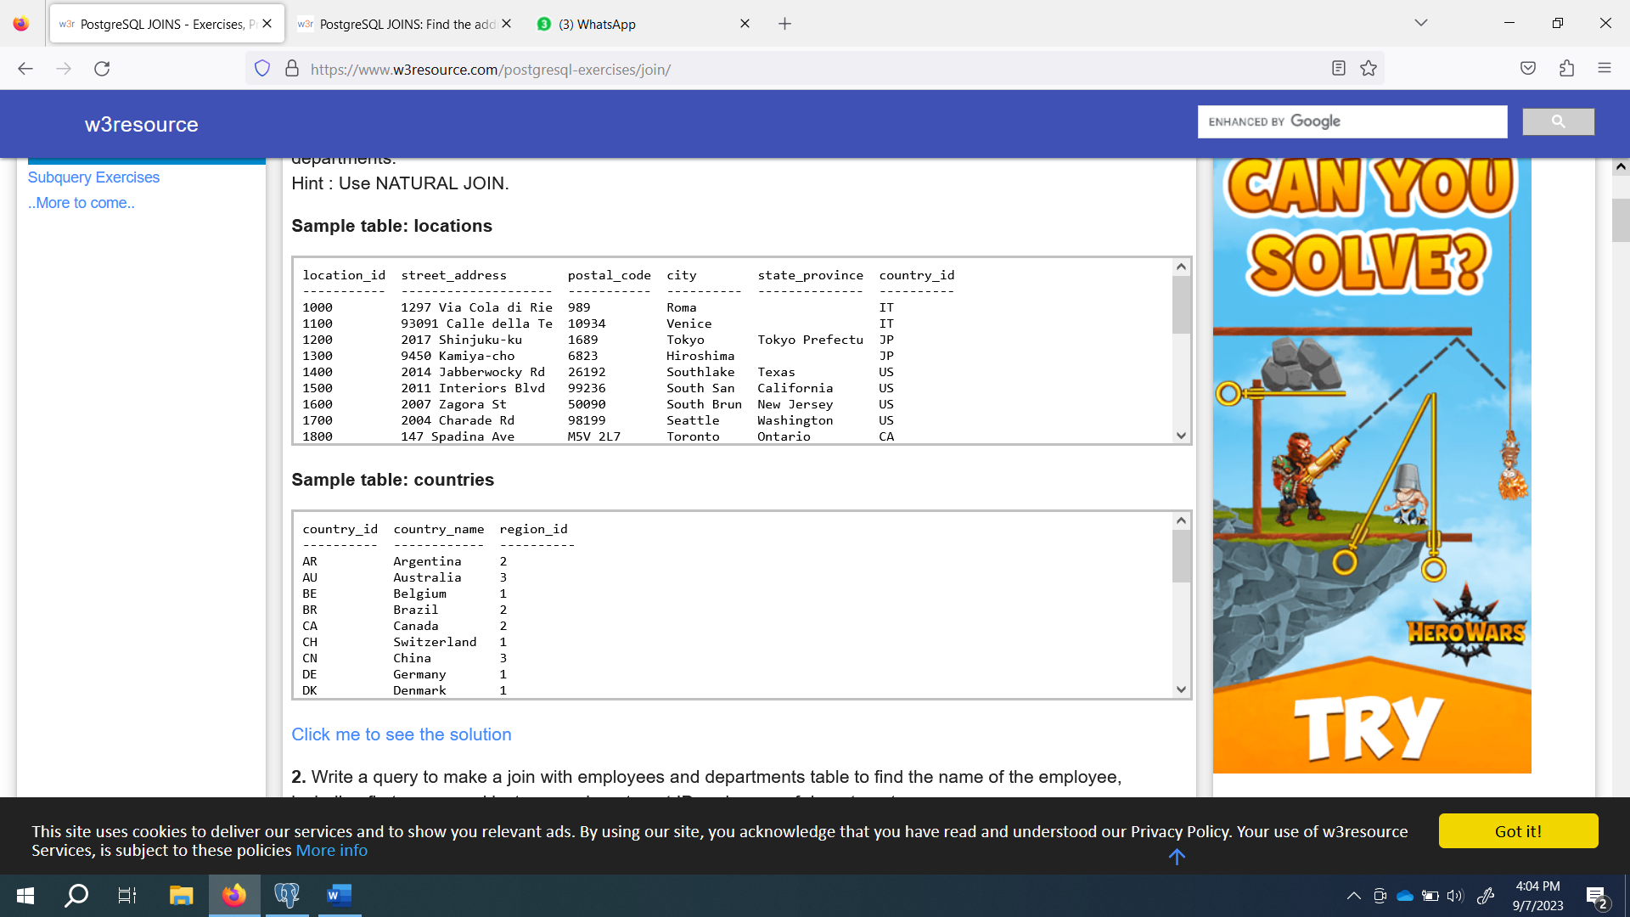

Write a query to make a join with employees and departments table to find the name of the employee, including first_name and last name, department ID and name of departments.

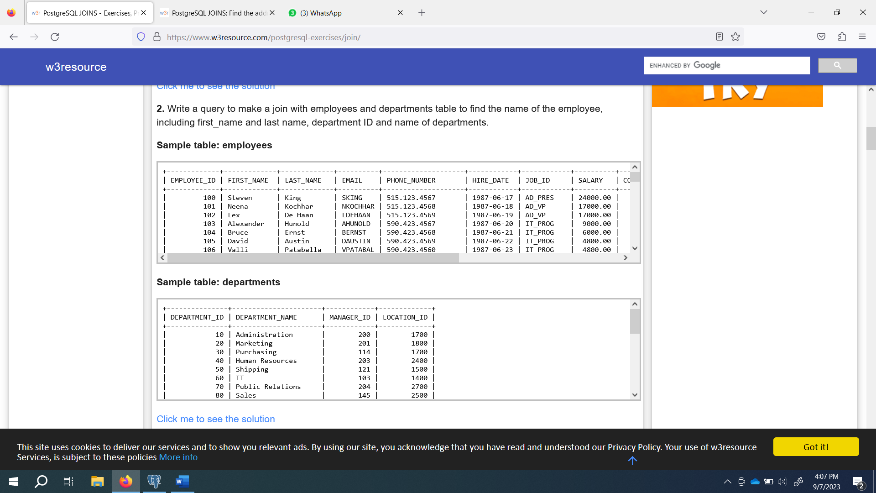

--assigment

--Write a query to find the addresses

--(location_id, street_address, city, state_province, country_name)

--of all the departments.

drop table location ;

create table location(

location_id serial not null ,

street_address varchar(300) not null,

postal_code int not null,

city varchar(200) not null,

start_province varchar(200),

country_id varchar(200) not null);

create table if not exists countries(

country_id varchar(200) not null,

country_name varchar(45),

region_id decimal(10,0) not null);

select location_id, street_address, city,

start_province, country_name

from location inner join countries

on location.country_id= countries.country_id;

--

--Write a query to make a join with employees and departments table to

--find the name of the employee, including first_name and last name,

--department ID and name of departments

create table employee(

employee_id serial not null ,

first_name varchar(300) not null,

last_name varchar(200) not null,

email varchar(200) not null unique,

phone_number varchar(20) not null,

hire_date date ,

job_id varchar(200) not null,

salary decimal(6,0) not null);

drop table departments;

create table departments

(

department_id serial not null,

departement_name varchar(120) not null,

manger_id serial not null,

location_id varchar(2000) not null);

select first_name,last_name ,department_id ,

departement_name from employee inner join departments

on employee.employee_id=departments.manger_id;